Termwork 2

Name:Chidambar

USN: 2GI20CS031

Date: 16/05/2023

SQUARE WAVE

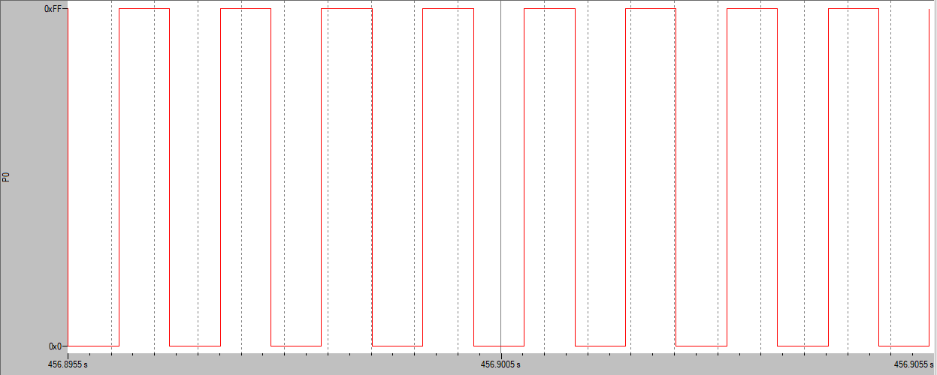

TRIANGULAR WAVE

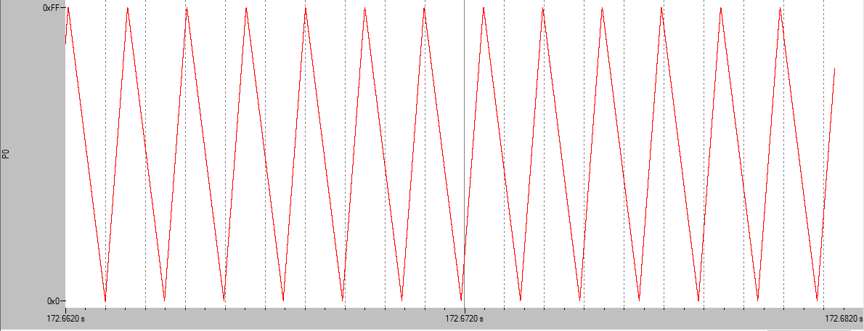

RECTANGULAR WAVE

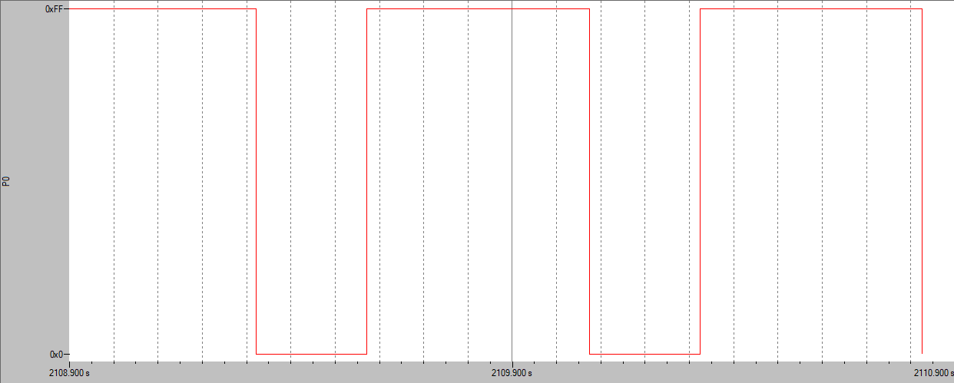

POSITIVE RAMP

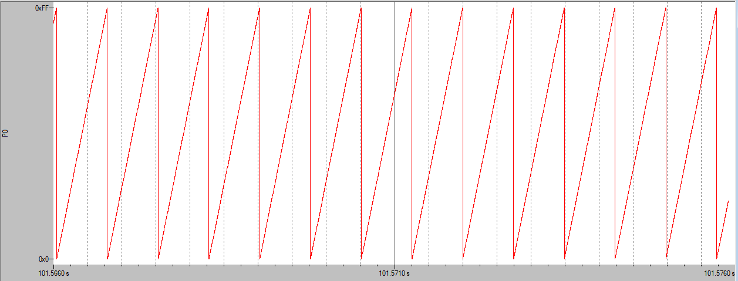

NEGATIVE RAMP

